Module 7
\
ANSWERS TO QUESTIONS FROM THE TEXT

Review Questions from Section 7.2:

Q. 1 Information representation by electrical signals; transistors; and photography
(and thus printed circuits).

Q. 2 “p IMPLIES q” is equivalent to “NOT (p AND NOT(q))” or to “NOT (p) OR q”.
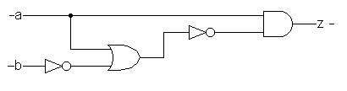
Q. 3

Q. 4 (In the following table, the symbol ‘ stands for “NOT”)

a | b | b’ | a OR b’ | (a OR b’)’ | a AND (a OR b’)’
off | off | on | on | off | off
off | on | off | off | on | off
on | off | on | on | off | off
on | on | off | on | off | off

